**Chapter Three: Specific requirement**

**3.1 Use case scenario**

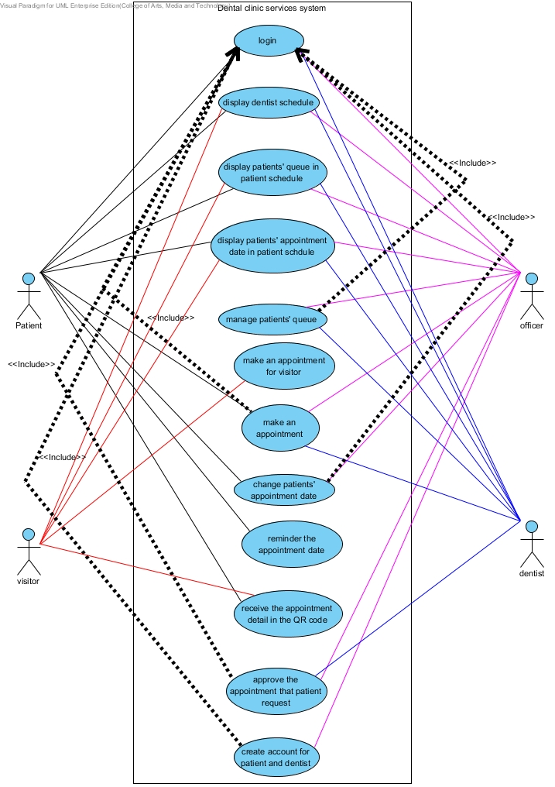

Figure 1: Dental clinic services system use case diagram

**Patient**

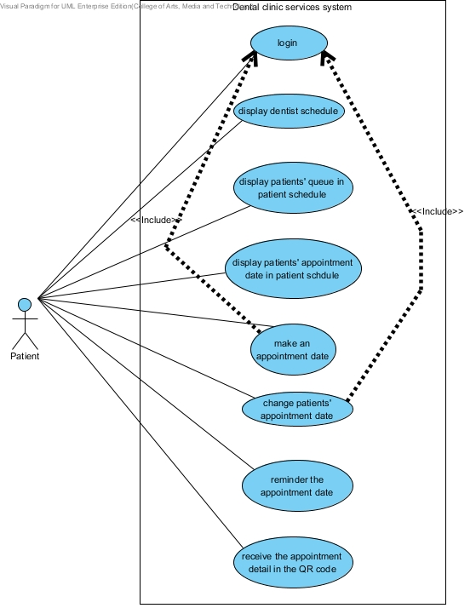

**Visitor**

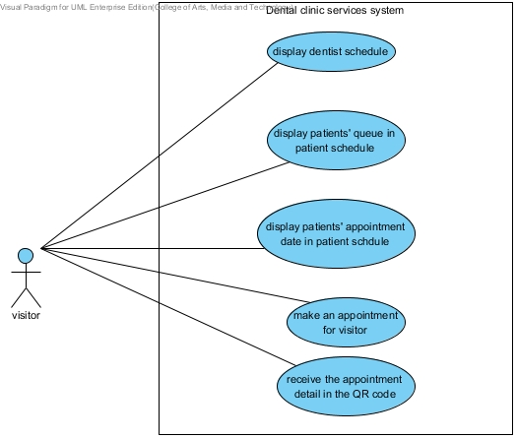

**Officer**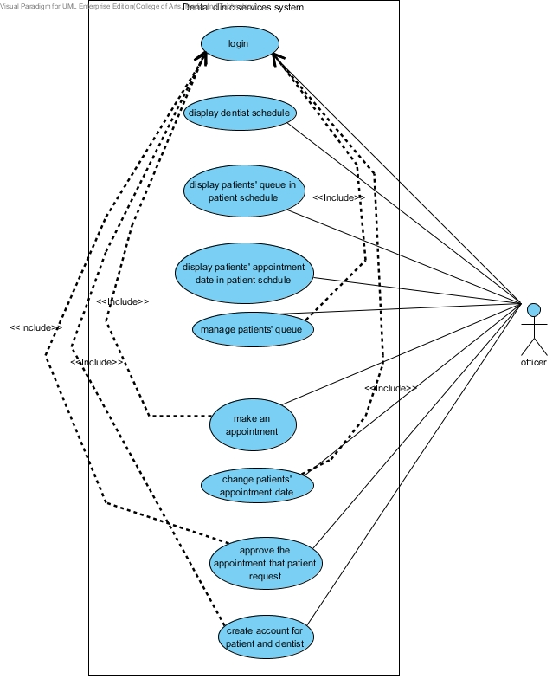

**Dentist**

